**Multiphase and Grain Size Analysis**

| Form |
| --- |

| Table |
| --- |

**Multiphase Overall Measurement Results**

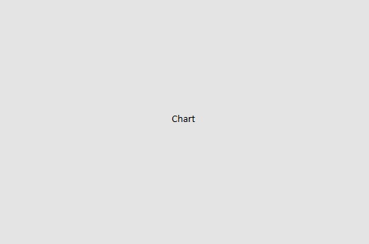

| Table |
| --- |

|  |  |  |  |  |  |  |  |  |  |
| --- | --- | --- | --- | --- | --- | --- | --- | --- | --- |
| | Phase | Color | Count | Area % | | --- | --- | --- | --- | | Phase 1 | #FFFF0000 | 0 | 0 | |  |

**Grain size overall measurement data**

Grain Size Results

| Table |
| --- |

Grain size overall statistics

| Table |
| --- |

Grain Size (in µm²) Distribution over all images

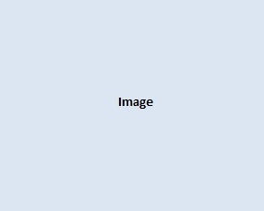

Grains area percentage distribution over all images



Measurements

Original Image

|  |  |  |  |  |  |
| --- | --- | --- | --- | --- | --- |
| |  |  |  |  |  | | --- | --- | --- | --- | --- | | |  | | --- | |  | | |  |  | | --- | --- | | **File Name** | <File Name> | | | |

Multiphase Analyzed Image

|  |  |  |
| --- | --- | --- |
| |  |  | | --- | --- | | |  | | --- | |  | | |



| Table |
| --- |

|  |  |  |  |  |  |  |  |  |  |
| --- | --- | --- | --- | --- | --- | --- | --- | --- | --- |
| | Phase | Color | Count | Area % | | --- | --- | --- | --- | | Phase 1 | #FFFF0000 | 0 | 0 | |  |

Grain SIze Analyzed Image

| Table |
| --- |

|  |  |
| --- | --- |
| |  | | --- | |  | |

Grain size distribution



Grain size results

| Table |
| --- |

Grains area percentage chart

